

C PROGRAMMING LAB FILE
(1st Semester)

Name:- Sparsh Srivastava
SAP ID :- 590022251
Batch 33

Experiment 1: Installation, Environment Setup and starting with C language
- Write a C program to print “ Hello World”
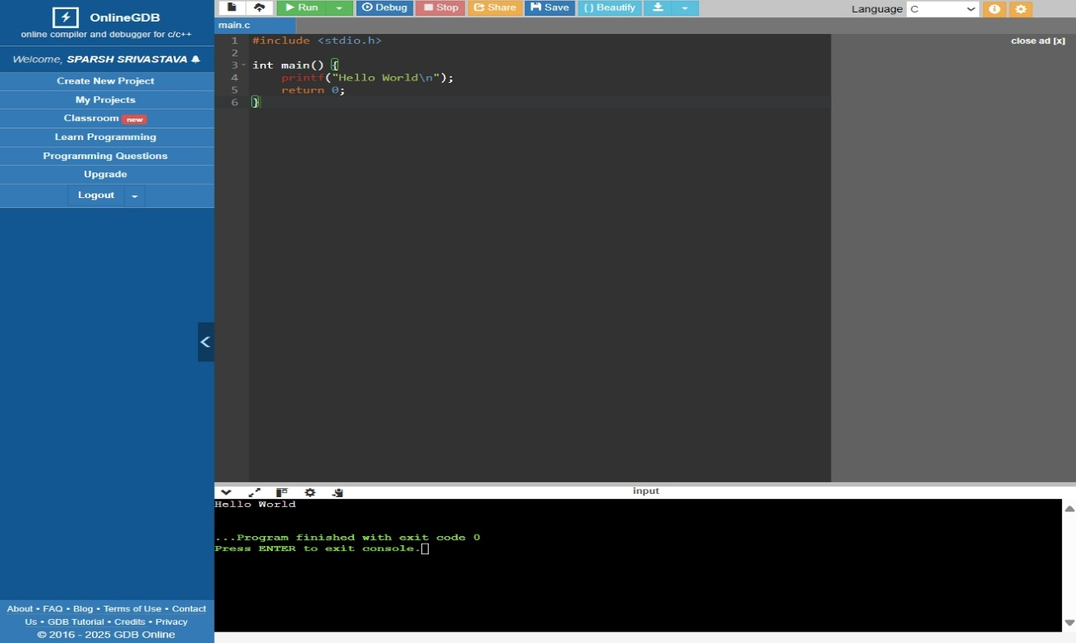

- Write a C Program to print the address in multiple lines (new line)
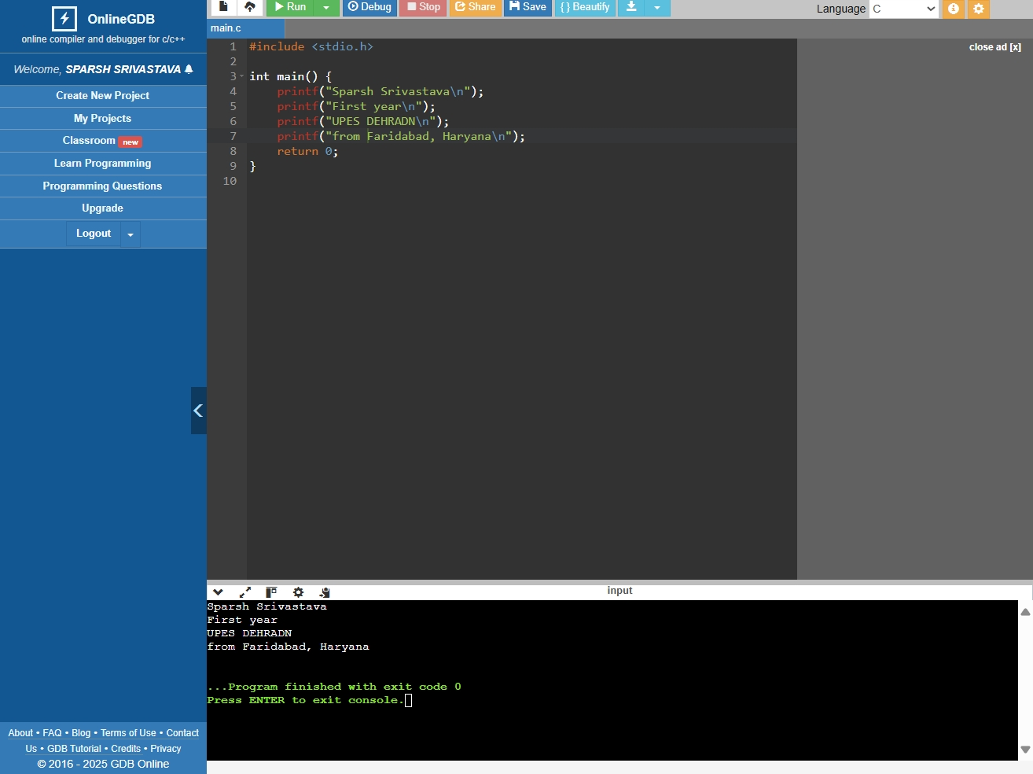

- Write a program that prompts the user to enter their name and age.
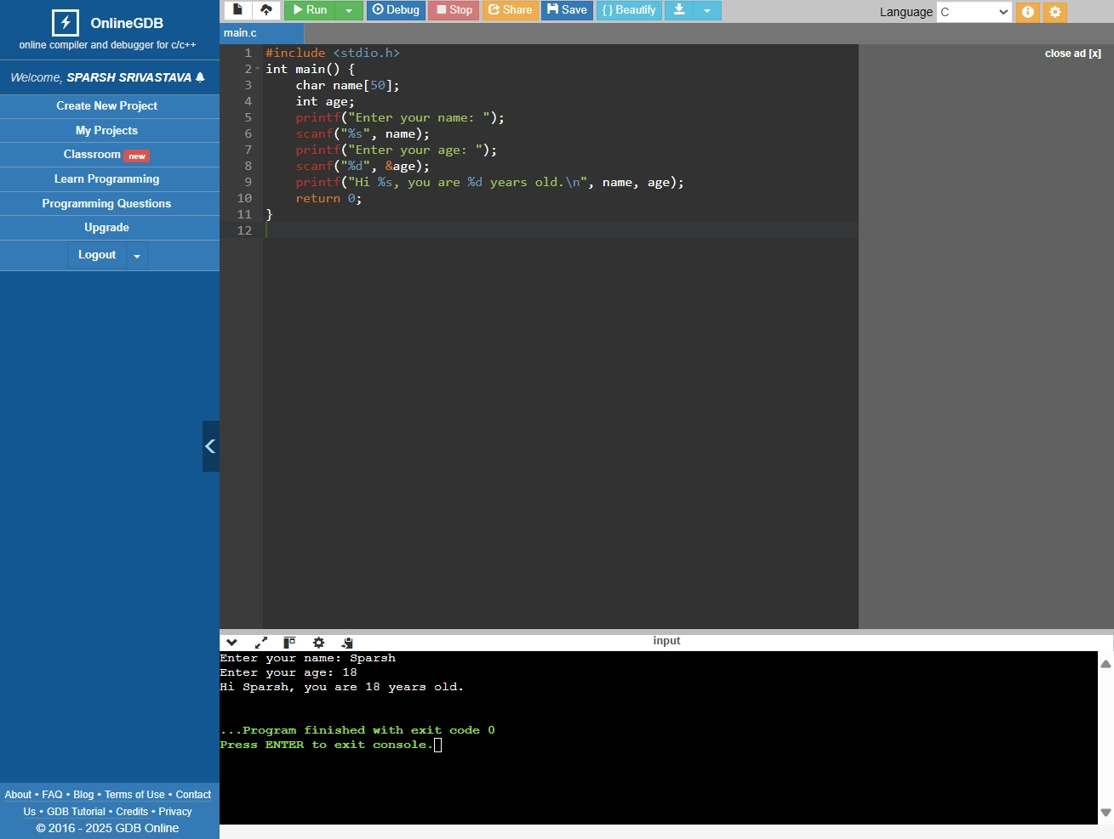

- Write a C program to add two numbers, take number from user.
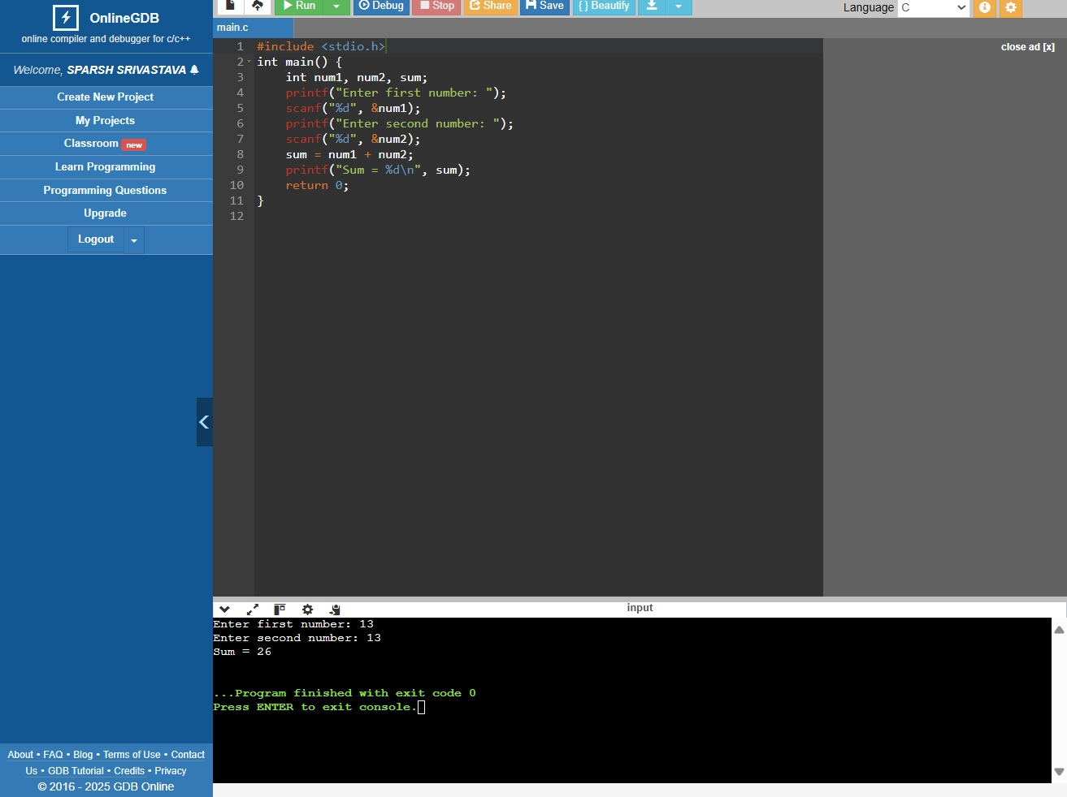

Experiment 2: Operators:

- WAP a C program to calculate the area and perimeter of a rectangle based on its length and width.
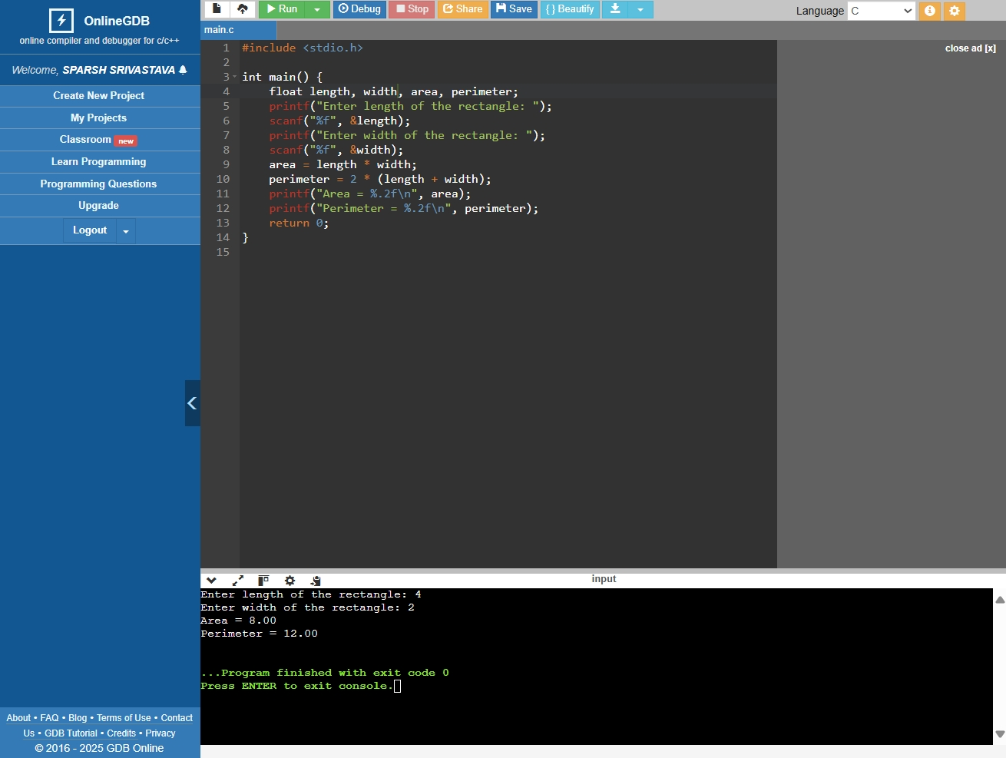

- WAP a C program to Convert temperature from Celsius to Fahrenheit using the formula: F = (C * 9/5) + 32.
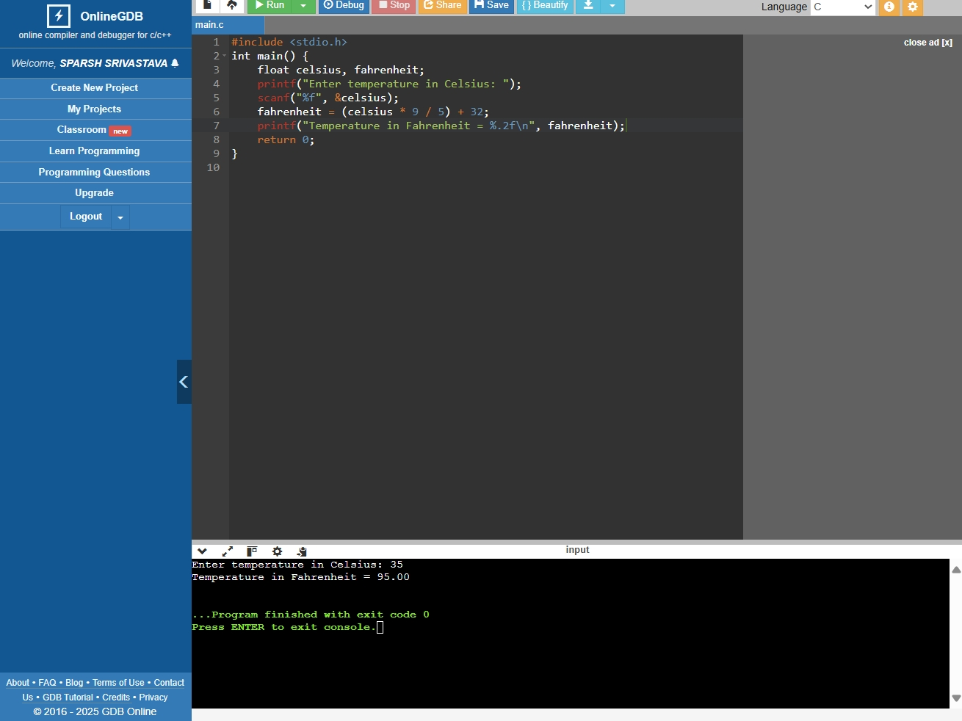

Experiment 3.1: Conditional Statements
- WAP to take check if the triangle is valid or not. If the validity is established, do check if the triangle is isosceles, equilateral, right angle, or scalene. Take sides of the triangle as input from a user.
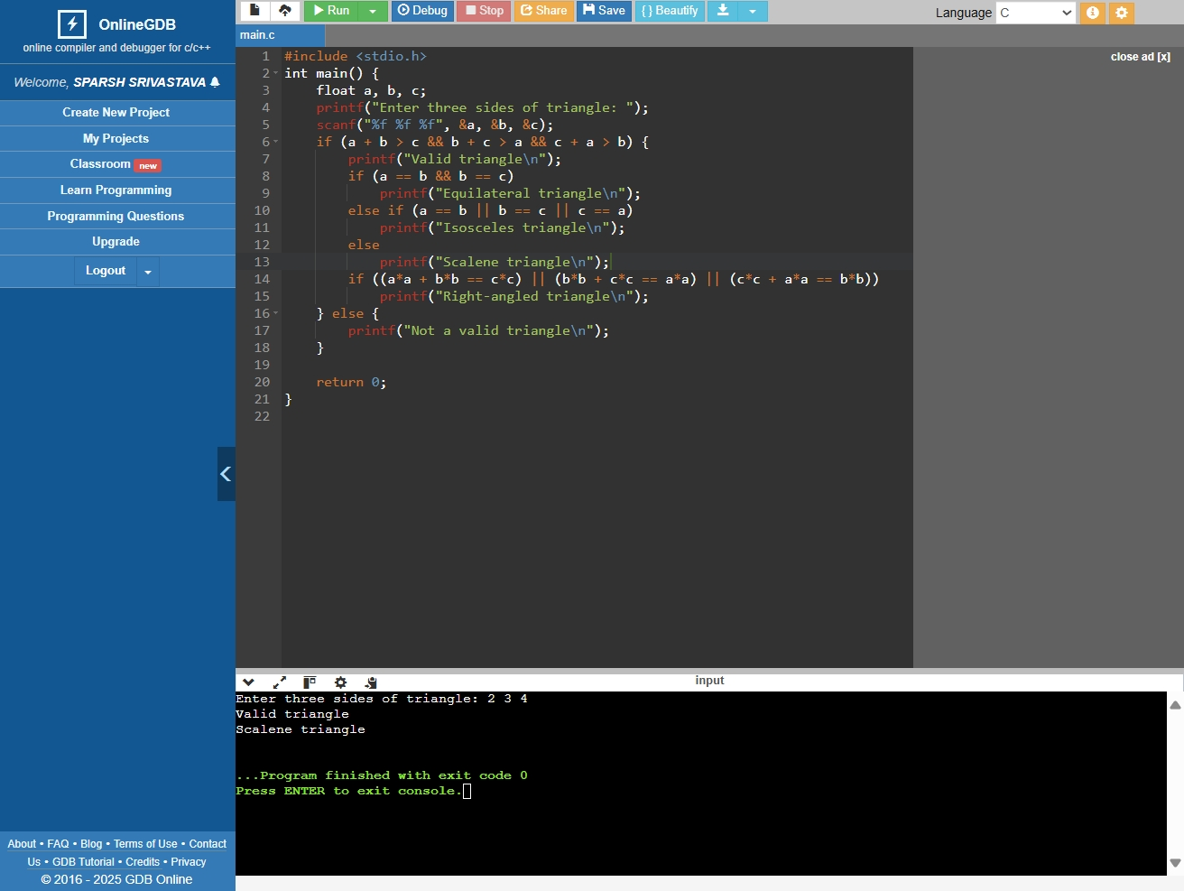

- WAP to compute the BMI Index of the person and print the BMI values as per the following ranges. You can use the following formula to compute
BMI= weight(kgs)/Height(Mts)*Height(Mts).
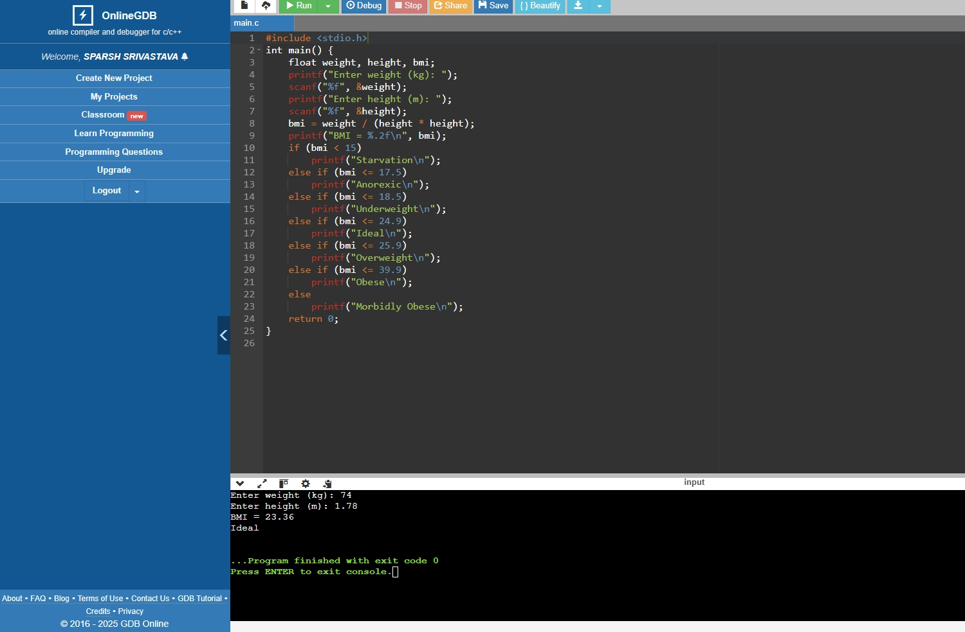

- WAP to check if three points (x1,y1), (x2,y2) and (x3,y3) are collinear or not.
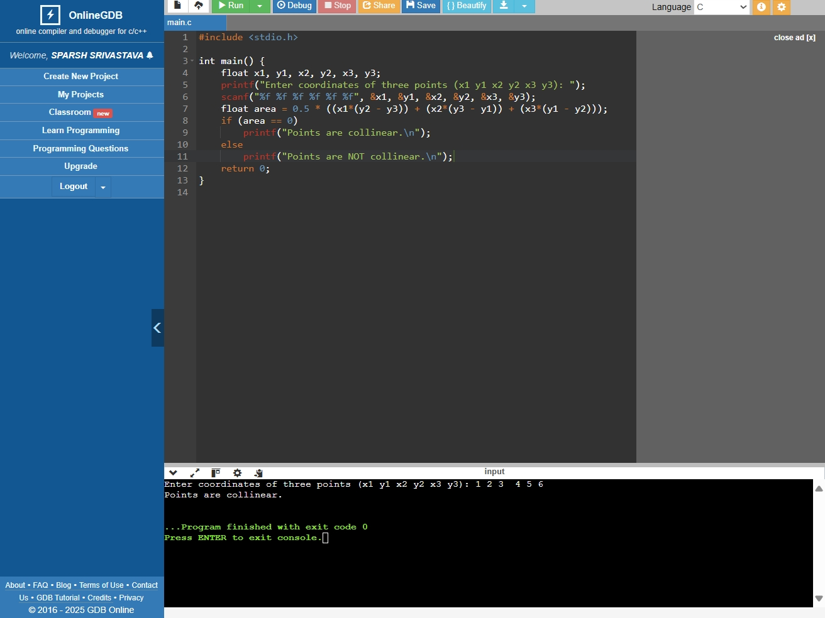
- According to the gregorian calendar, it was Monday on the date 01/01/01. If Any year is input through the keyboard write a program to find out what is the day on 1st January of this year.
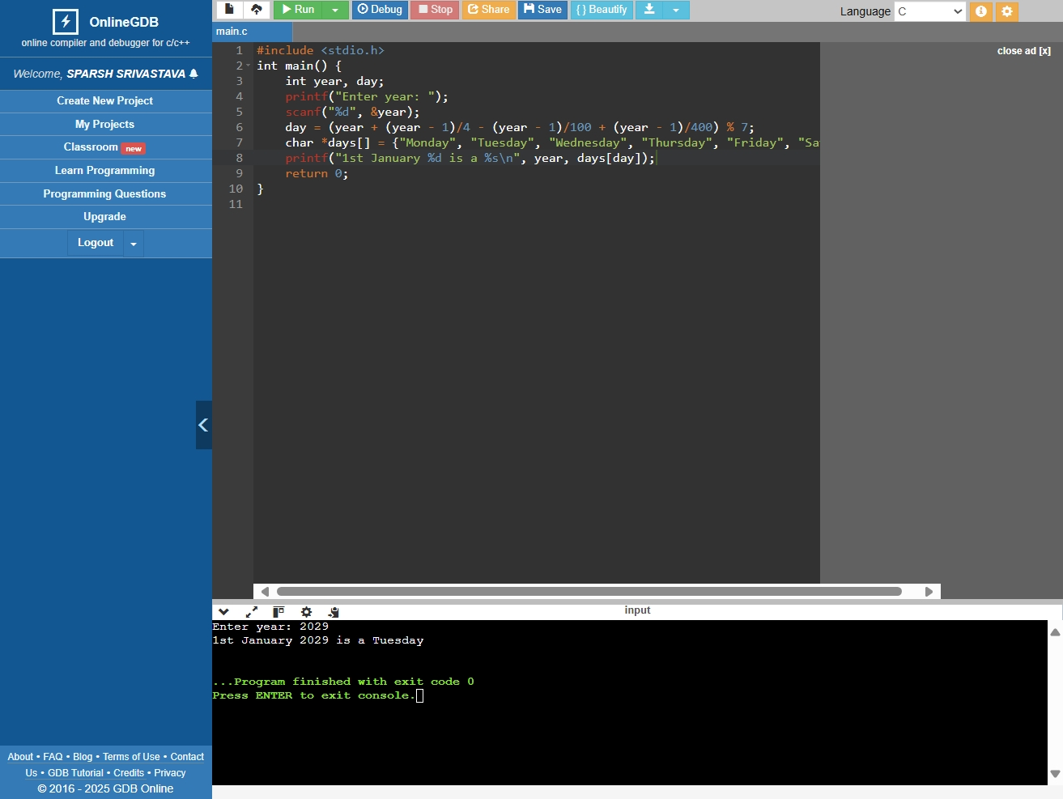
- WAP using ternary operator, the user should input the length and breadth of a rectangle, one has to find out which rectangle has the highest perimeter. The minimum number of rectangles should be three.
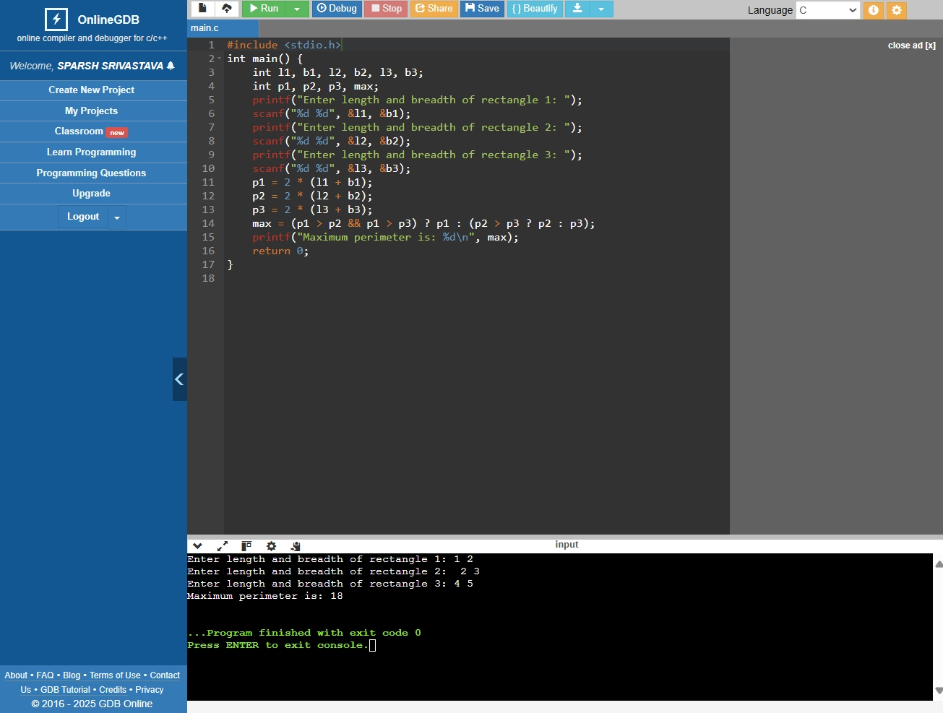

Experiment 3.2: Loops

- WAP to enter numbers till the user wants. At the end, it should display the count of positive, negative, and Zeroes entered.

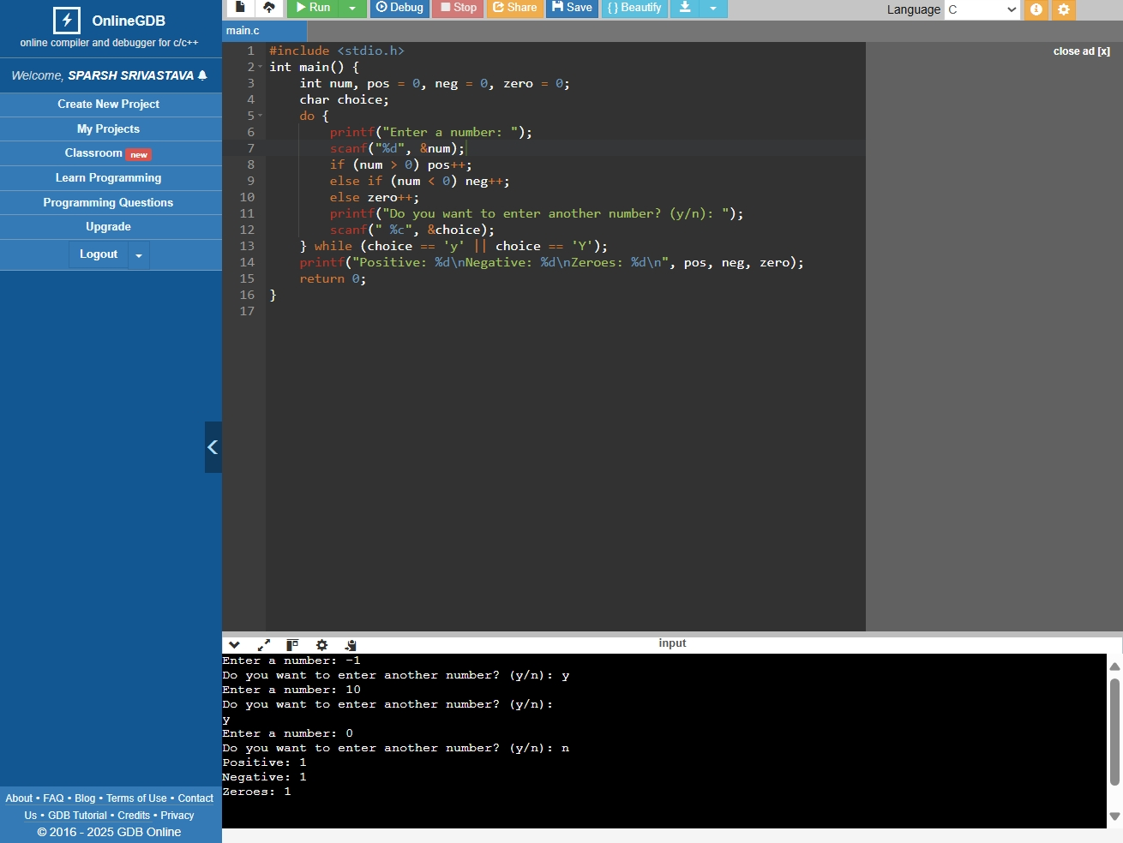

- WAP to print the multiplication table of the number entered by the user. It should be in the correct formatting. Num * 1 = Num

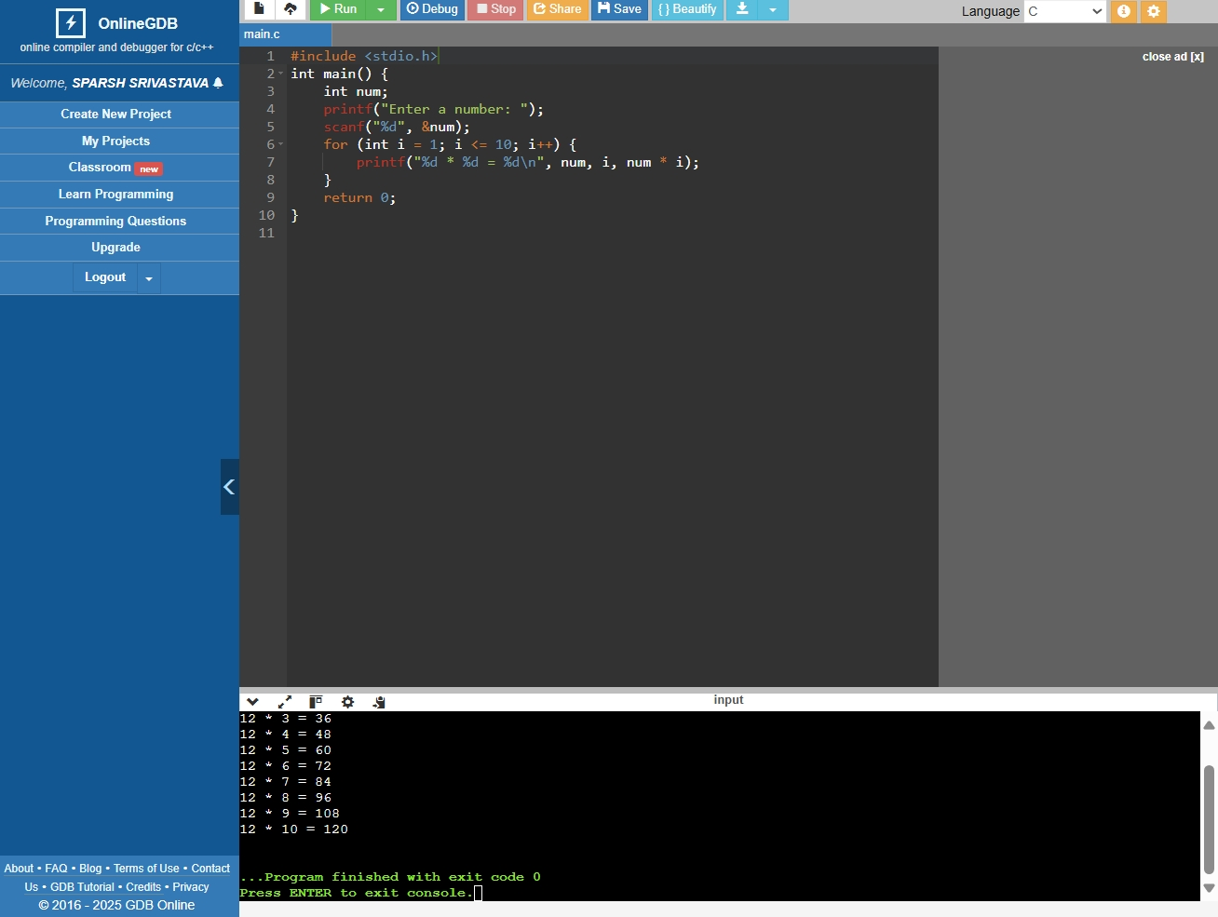

3. WAP to generate the following set of output.
a. 1
2 3
4 5 6
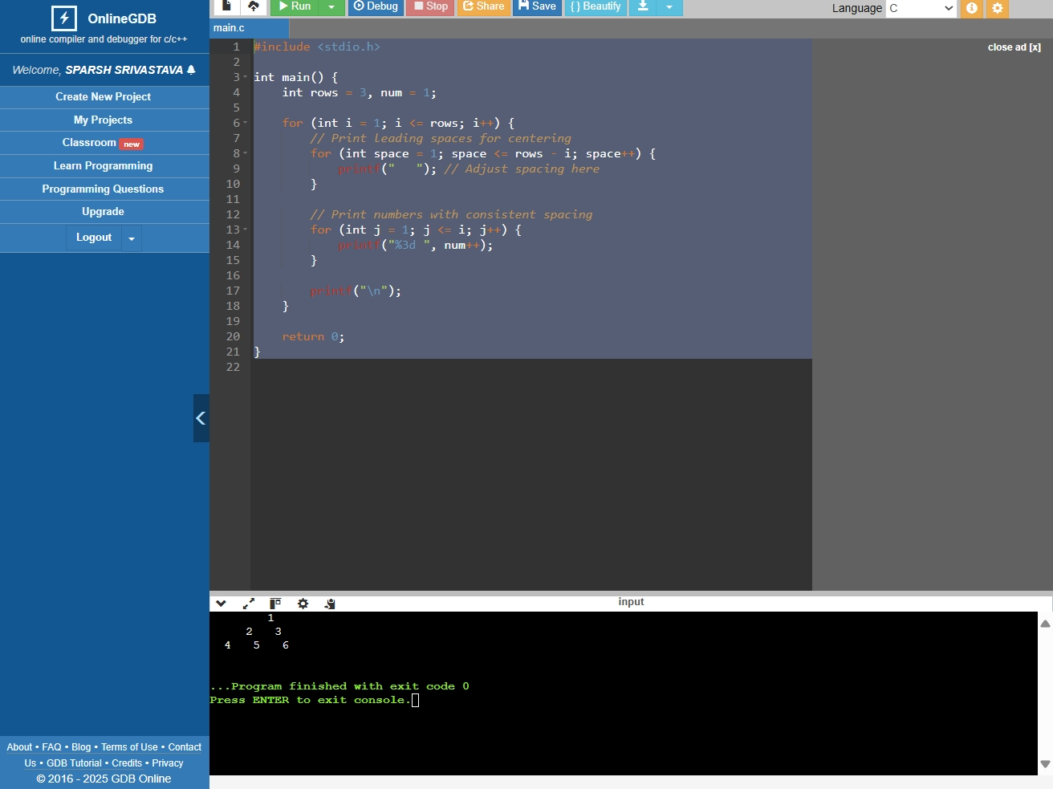

b. 1
1 1
1 2 1
1 3 3 1
- 4 6 4 1

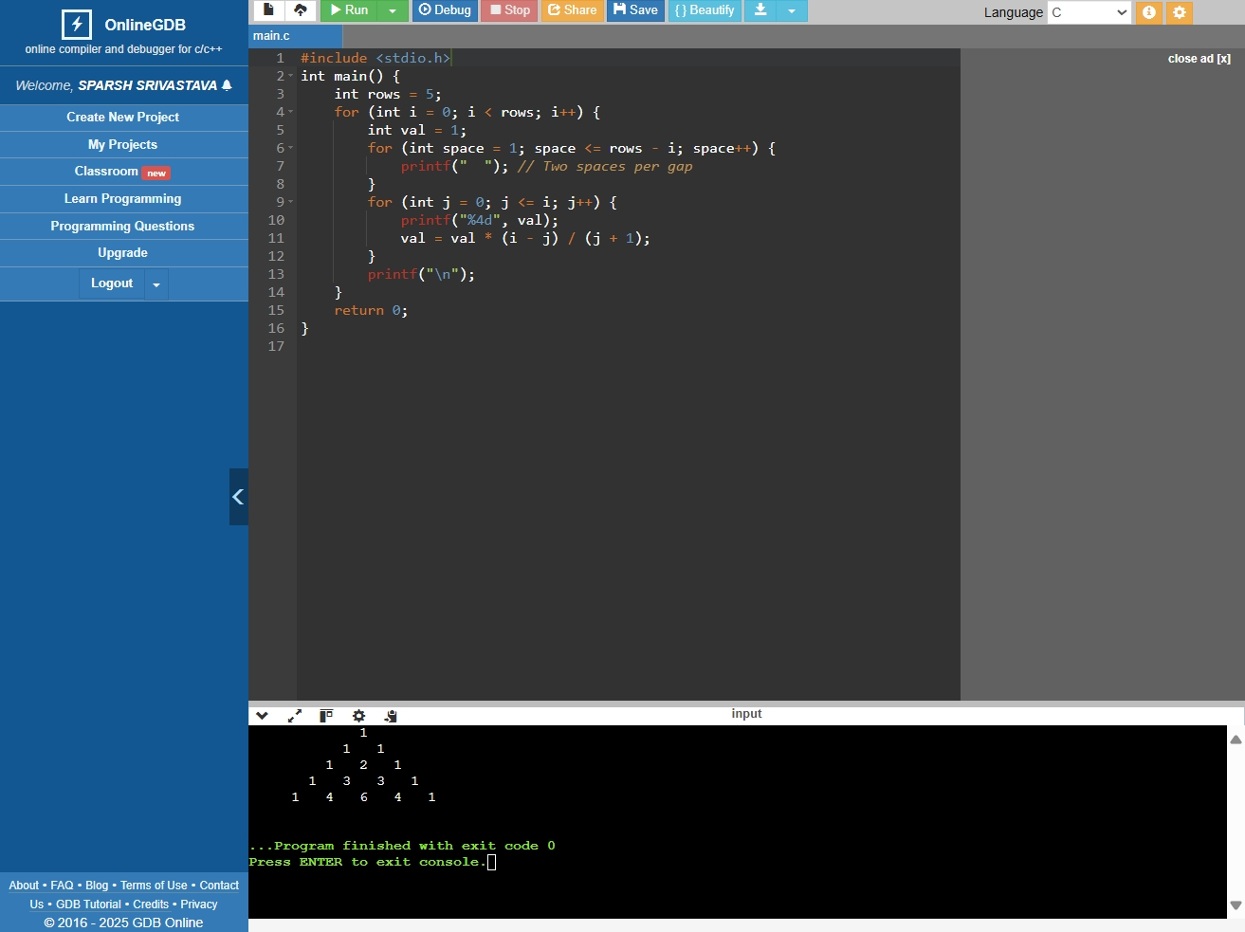
4. The population of a town is 100000. The population has increased steadily at the rate of 10% per year for the last 10 years. Write a program to determine the population at the end of each year in the last decade.
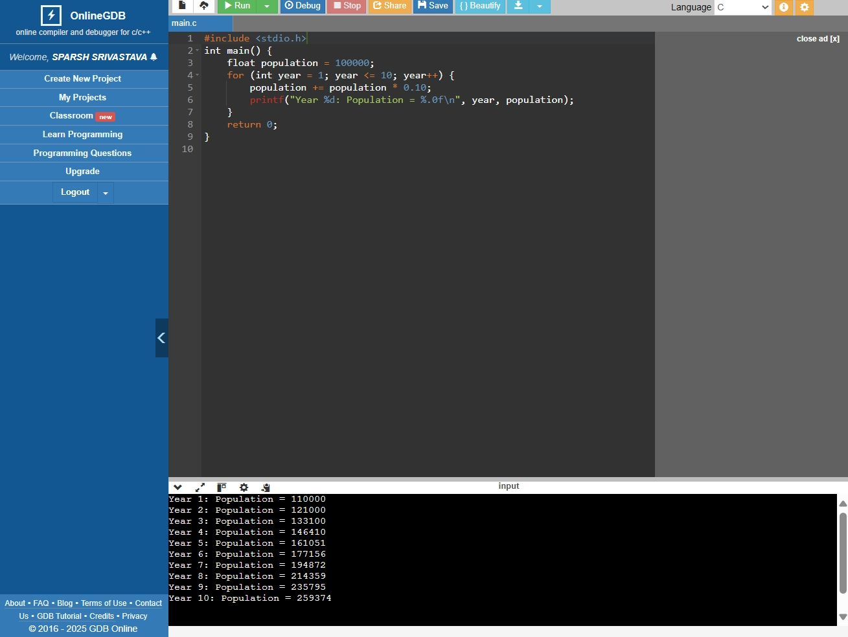

5. Ramanujan Number is the smallest number that can be expressed as the sum of two cubes in two different ways. WAP to print all such numbers up to a reasonable limit. Example of Ramanujan number: 1729 12^3 + 1^3 and 10^3 + 9^3. for a number L=20(that is limit)
